ASSESS THE RISK OF A TERMITE ATTACK ON YOUR HOUSE

HOW SUSCEPTIBLE IS YOUR PROPERTY TO TERMITE ATTACK?
Answer these 12 questions, tally up your score and check your risk factor below.
1. | Storm water. Any wastewater not directed well away from the building could attract termites by providing a continuous moisture supply under or next to the building. Termites will follow plumbing pipes into buildings & enter through the concrete floor slab via service penetrations.  Q. Are all sources of wastewater (downpipes etc) directed away from the building?
  YES | 0 points
  NO | 7 points
  Not Sure | 5 points
2. | SUBFLOOR VENTILATION. If your structures have suspended floors, subfloor dampness may attract termites. Inadequate ventilation causes moisture build-up, fungus growth, odour & rot. These can all lead to increased termite activity.  Q. Does your building have adequate ventilation in all foundation walls?
  YES | 0 points
  NO | 7 points
  Not Sure | 5 points
3. | AIR CONDITIONERS. Condensation from operating units allows water to drip continuously onto the ground. This can sometimes be the only source of moisture for termites during hot, dry weather. It is a proven way to attract termites to a building. Q. Is water run off from your air conditioner piped and directed well away from the building?
  YES | 0 points
  NO | 5 points
  Not Sure | 3 points
4. | SLAB EDGE EXPOSURE. Termites commonly build mud tunnels that bridge the concrete slab edge/footing. Built up footpaths, paving, rendering, soil, lawns etc. covering the slab edge, can easily enable termites to gain concealed entry.  Q. Is the edge of your concrete slab visible around the entire perimeter of the building?
  YES | 0 points
  NO | 10 points
  Not Sure | 8 points
5. | OBSTRUCTIONS. Anything located hard up against the building &/or slab edge can provide concealed termite entry. Examples include a hot water service, air-conditioning ground unit, stacked timber, dog kennels, downpipes etc.  Q. Are there any objects obstructing viewing &/or access to areas around the outside of the building?
  YES | 5 points
  NO | 0 points
  Not Sure | 3 points
6. | GARDEN BEDS. Both plants and termites need water. Gardens & watering systems next to buildings provide a continuous moisture source, while beds, plants and vines against a building allow concealed termite entry.  Q. Are there garden beds, plants or tree roots closer than 1 metre to the building?
  YES | 5 points
  NO | 0 points
  Not Sure | 3 points
7. | BUILDING LINE ON THE BOUNDARY.  Town houses, units etc. can inhibit inspection access, while neighbouring activity may bridge your slab edge & will obstruct visual inspection. Pest professionals would require the neighbours written approval to apply termiticide or monitoring devices.  Q. Are one or more sides of your building located on the property boundary?
  YES | 8 points
  NO | 0 points
  Not Sure | 7 points
8. | TIMBER / SOIL CONTACT. Timber walls, fences, pergola posts, decking, house stumps, etc. in contact with the ground provides food for termites & cannot have an effective chemical barrier installed around or beneath it.  Q. Do you have fence/pergola/decking posts, sleepers etc. directly on or in the ground?
  YES | 10points
  NO | 0 points
  Not Sure | 8 points
9. | EXTERIOR EVIDENCE. Termite evidence in the yard means the building may also be at risk. Check for damaged timber by using a screwdriver to probe. Check fences, sheds, pergolas, garden stakes, cubby house etc.  Q. Have you discovered any evidence of timber damage in your yard?
  YES | 12 points
  NO | 0 points
  Not Sure | 12 points
10. | INTERIOR EVIDENCE. Termite evidence in a building is a serious concern. Look for mud tunnels along timbers. Gently tap timber doorframes, skirtings, floorboards etc. with a screwdriver handle, listening for a dull or hollow sound. Check dark corners of inbuilt cupboards/robes & inspect roofing timbers.  Q. Have you discovered evidence of termite activity anywhere inside the building?
  YES | 25 points
  NO | 0 points
  Not Sure | 25 points
11. | TERMITE BARRIER SYSTEM INSTALLED. In most cases, it became compulsory to install a termite barrier complying with AS3660 to Homes built after 1995, Many homes built before 1995 also had termite barrier installed Q. Does you meter box or cupboard contain a label confirming that a termite treatment zone has been installed/applied?
  YES | 0 points
  NO | 15 points
  Not Sure | 10 points
12. | Q. Have you had a professional termite inspection or a termite  Treatment carried out for any reason in the last 12 months?
  YES | 0 points
  NO | 15 points

ASSESS YOUR RISK - ADD THE TOTAL SCORE FROM ALL QUESTIONS TOTAL SCORE __________
Termite Risk: (0 -19) Low; (20-34) Moderate; (35-65) High; (65+) Extreme Risk

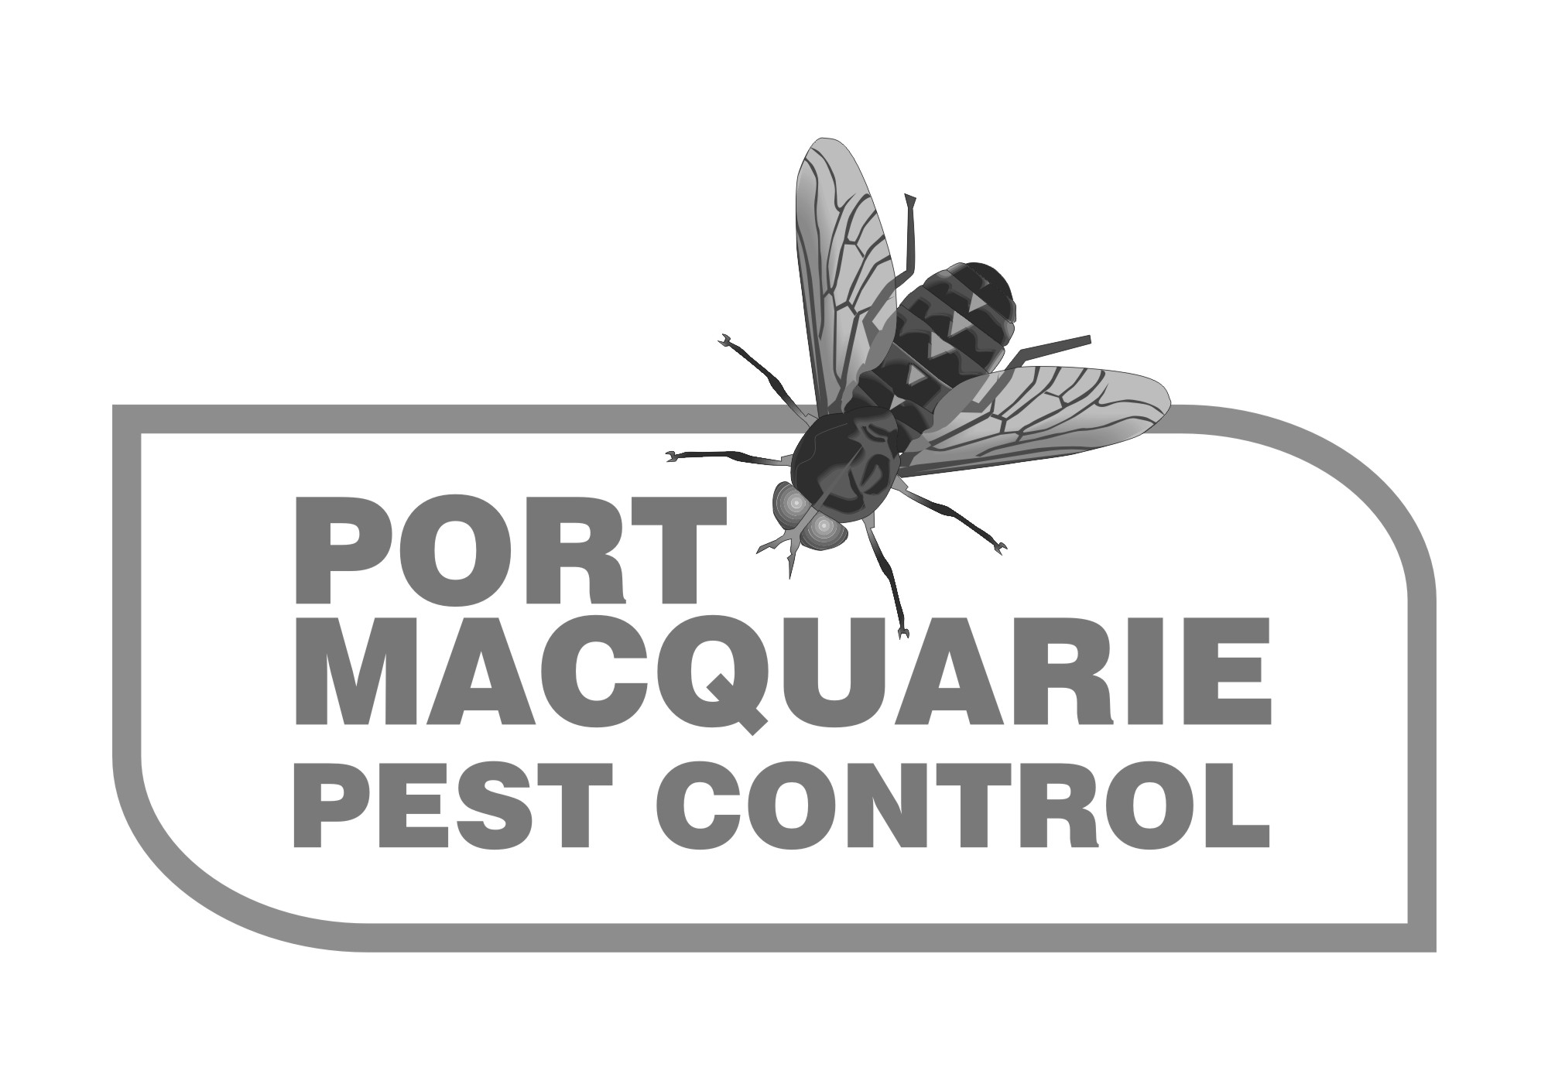
In accordance with Australian Standard 3660, we strongly recommend that all buildings should
have a professional termite inspection at least every 12 months.
If you have assessed your risk as ' High ' or ' Extreme Risk ',
we suggest you call us to provide a Termite Inspection.

